A REPORT

ON

STUDENT RECORD MANAGEMENT SYSTEM

By

Name of the Student: Registration No. :

Bishu Sharma AP24110012115

Prepared in the partial fulfillment of the
Project Based Learning of Course CSE 201 – Coding Skills-I



SRM UNIVERSITY, AP
DECEMBER 2025

Acknowledgements

I would like to express my profound gratitude to everyone who supported me throughout the successful completion of this project.
First and foremost, I thank the Head of the University and the Dean of the School of Engineering for providing a motivating academic environment and all necessary resources.
My sincere appreciation goes to my Faculty Mentor, Mr. Rakesh Rama Raju P, for his continuous guidance, valuable insights, and encouragement. His expertise played a crucial role in shaping this work and enhancing my understanding of programming concepts.
I am also grateful to my classmates and friends for their suggestions, collaboration, and support during the development of the Student Record Management System.
Finally, I extend heartfelt thanks to my family, whose support and motivation have always inspired me to excel.

CERTIFICATE

This is to certify that the project entitled Student Record Management System(Using C) has been successfully completed by Bishu Sharma (Roll Number: AP24110012115) as a required academic component of the course Course CSE 201 – Coding Skills-I during Semester 3 of Academic Year 2025-26 in the Department of Computer Science and Engineering at SRM University, AP. This work was executed under the guidance of the undersigned and is deemed to have successfully met all course requirements as of 06-12-2025.

(Signature of the Course Instructor)

Mr. Rakesh Rama Raju P

Table of Content

Serial  Number | Title | Page Number
1. | Cover page | 1
2. | Acknowledgements | 2
3. | Certificate | 3
4. | Table of Contents | 4
5. | Introduction | 5-7
6. | Abstract Sheet | 8-9
7. | Report | 10-18
8. | Outcomes | 19
9. | Conclusions | 19
10 | References | 20

INTRODUCTION TO PROJECT REPORT

Background
Managing student academic records is a fundamental requirement in educational institutions. Traditionally, maintaining student details, marks, grades, and records has been performed manually, making the process time-consuming, less secure, and prone to mistakes.
To address these challenges, this project implements a Student Record Management System in C, which automates the storage, retrieval, updating, and deletion of student records using structured programming concepts and file handling.
The program supports authentication-based roles (Admin/Staff/User), ensuring controlled access to sensitive student data.

Objectives

To design a secure, menu-driven C application for managing student data.

To implement role-based access control (Admin, Staff, User).

To allow storing, updating, deleting, and retrieving student records through file handling.

To automatically compute total, average, and grade from subject marks.

To apply concepts such as structures, file handling, string manipulation, input validation, and modular programming.

Problem Definition
Preparing report cards manually involves repeated calculations, handwritten entries, and difficulty in updating or retrieving old records.
Such manual processes result in:
Manual Problems:
- Risk High possibility of calculation mistakes in total, average, or grade
- Time-consuming work when handling multiple students
- Difficulty in searching or modifying previous entries
- Lack of proper digital storage or organized record keeping

Solution
The Student Record Management System in C serves as a comprehensive solution to the problems outlined above. The system automates the entire workflow and ensures secure, accurate, and user-friendly management of student data.

Key Features of the Solution
- Automated Grade Calculation
The system computes the grade based on the average of Physics, Chemistry, and Math marks, using consistent grading logic within the function compute_grade().
- Permanent and Organized Storage
Student records are stored in the file students.txt, ensuring persistence even after the program closes.
Data is stored in a comma-separated format:
- Role-Based Access Control (RBAC)
The system reads users and roles from credentials.txt:
- Admin: Full CRUD + Add User
- Staff: Add/Update/Search/View
- User: Search + View only
This prevents unauthorized access and secures sensitive data.
4. Case-Insensitive Name Search
Searching is improved through substring matching using ci_substr(), allowing
fast user friendly lookups.
5. Portable Password Masking
Passwords entered during login are masked with * characters,
ensuring confidentiality.
This works on both Windows and Linux using:
- <conio.h> (Windows)
- termios.h (Linux/Mac)
6. Search, Update, and Delete Functionalities
The system supports:
- Searching by ID
- Searching by name substring
- Updating complex fields (name, gender, marks)
- Deleting student records with confirmation prompts
7. User-Friendly Menu Interface
The system presents clear, controlled menus for each role, ensuring smooth
navigation.

This project demonstrates efficient program structuring through the following C concepts:

C Concepts Used

Structures (struct): The program uses structures to group related data.
Student stores ID, name, gender, subject marks, and grade, while
Credential stores username, password, and role.
Structures help organize data in a way similar to simple objects.

Arrays & Strings: Fixed-size character arrays are used to store names, genders, and grades.C string functions such as strtok(), strncpy(), and strcspn() enable parsing input, handling text, and processing comma-separated file data.

Functions: All major tasks—adding, updating, deleting, searching, viewing, loading, and saving—are implemented through separate modular functions.
This improves maintainability and ensures a clean program structure.

File Handling: Permanent storage of records is implemented using text files (students.txt and credentials.txt).
The program uses fopen(), fprintf(), fgets(), fclose(), and scanf() for reading/writing structured data, enabling persistent storage even after termination.

Control Statements: if–else, switch, for, and while loops are used to perform menu operations, validate user input, compute grades, and control the flow of the program based on different role permissions.

Data Validation: Marks for Physics, Chemistry, and Math are checked using read_mark() to ensure values fall strictly between 0–100, preventing invalid or corrupted data.

• Password Masking: The login system uses <conio.h> (Windows) and <termios.h> (Linux/macOS) to hide characters during password input, improving data security.

• Case-Insensitive Search: A custom function (ci_substr()) allows searching student names without matching exact case, making the search process flexible and user-friendly.

System Functionalities
The system provides the following major features:
Data Entry & Storage
- Add a student's ID, name, gender, and marks in three subjects.
- Automatically compute total, average, and grade.
- Validate marks (0–100) before saving.
- Store all student records permanently in students.txt.

Record Retrieval & Management
- Display all stored student records.
- Search students by ID or name substring.
- Update student information or marks, with grade recalculated automatically.
- Delete a student’s record when needed.
- Reload and rewrite data from file to maintain updated records.
All records remain saved in students.txt, ensuring persistence even after the program is closed.

ABSTRACT
This project, Student Record Management System (Using C), is a console-based application designed to automate the management of student academic records through structured programming and efficient file handling techniques. The system eliminates the need for manual calculations by automatically computing the total marks, average score, and final grade for each student using a predefined grading logic.
The program collects essential student details such as ID, name, gender, and marks in Physics, Chemistry, and Mathematics, ensuring organized and uniform data entry. All student information is stored permanently in a structured, comma-separated format inside students.txt, allowing the system to load, update, and rewrite records whenever required.
Unlike object-oriented implementations, this C-based system uses structures, modular functions, and arrays to manage and process data. It incorporates a secure login system with Admin, Staff, and User roles, each providing different levels of access and functionality. Features include adding new students, searching records by ID or name substring, updating details, deleting records, and viewing complete student information. Password masking further enhances the security of user authentication.
The project improves accuracy and efficiency by automating repetitive tasks, reducing human error, and ensuring persistent storage of academic data. It is simple, reliable, and easy to use, and serves as a foundational system that can be extended with additional features such as a graphical interface, database integration, advanced reporting tools, and multi-subject support for broader usability.
GRAPHICAL ABSTRACT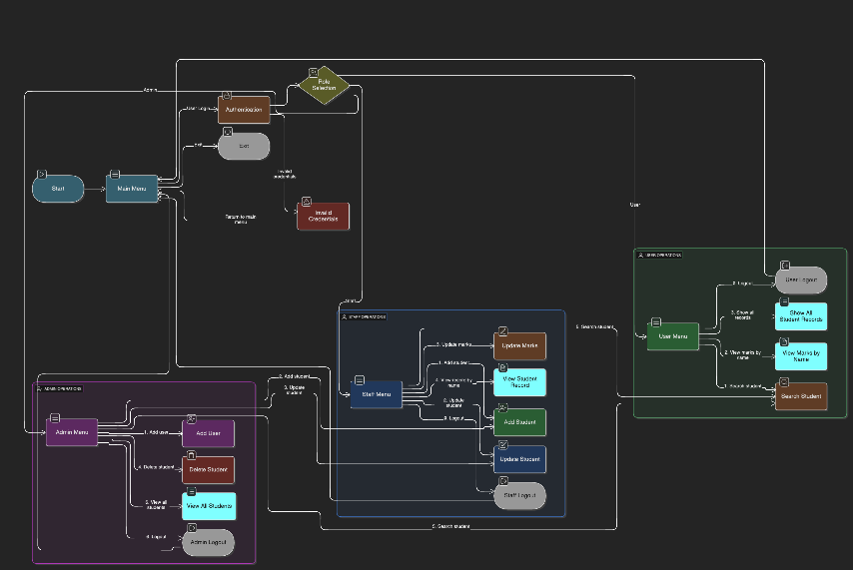

REPORT
This section provides a detailed breakdown of the system’s architecture, data flow, and the application of C programming principles exactly as implemented in the provided code

System Architecture and C Implementation Overview
The Student Record Management System is implemented using the procedural programming approach of the C language. The system is designed to securely collect, validate, calculate, store, retrieve, update, and delete student academic data using structures, modular functions, and file handling.
Instead of classes or objects, the system uses a well-structured Student struct, which groups all related details such as ID, name, gender, marks, total, average, and grade. A separate Credential structure is used for storing usernames, passwords, and roles for authentication.
The program operates through a menu-driven console interface, making interaction simple, intuitive, and role-based. Depending on whether the user logs in as an Admin, Staff, or User, the system displays the corresponding menu and available operations.
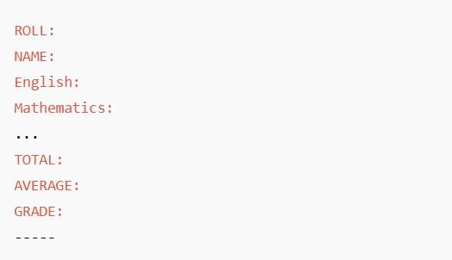
File handling is a key part of the architecture, where all student records are saved in a structured text file students.txt, using tags like:
This ensures permanent storage and accurate retrieval of data.

System Architecture
The Student Record Management System follows a modular, function-oriented architecture using the procedural programming model of C. Each module is responsible for one major task, making the program simple to maintain and easy to extend.
Module | Responsibilities
Input Module | Collects student ID, name, gender, and marks (validated 0–100).
Calculation Module | Computes total, average, and grade through compute_grade().
File Handling Module | Loads, stores, updates, and deletes records in students.txt using load_students() and save_students().
Display Module | Shows single or multiple records using print_student() and view_all_students().
Update/Delete Module | Edits or removes records and rewrites updated data to the file.
Menu Control Module | Directs program flow based on Admin, Staff, or User actions.
This structure ensures clear separation of logic and smooth coordination between modules.

Data Flow Description
The system follows a simple, linear, file-based data flow for all operations.
1. Input Phase
Users enter ID, name, gender, and marks.
- Implemented through: add_student()
- Marks are validated using read_mark() to ensure they fall between 0–100.

2. Processing Phase
The program calculates:
- Total
- Average
- Grade
Performed by:
- compute_grade() and internal logic during record updates.

3. Storage Phase
Student details are saved permanently in students.txt in comma-separated format:
id,name,gender,physics,chemistry,math,grade
Updates or deletions rewrite the file using save_students(), ensuring accurate and consistent storage.

4. Retrieval Phase
Records are loaded through load_students(), allowing users to:
- Search by ID or name
- Display all records
- Edit or delete entries (based on role permissions)
All data remains persistent even after the program exits.
OUTPUTS
This section displays the typical output stages generated by the C-based Student Record Management System. All outputs accurately reflect the behavior of the program, including user authentication, menu-driven navigation, student record operations, grade calculation, and file updates performed through students.txt

Program Startup Screen
When the program starts, the main menu appears, allowing the user to begin interaction:
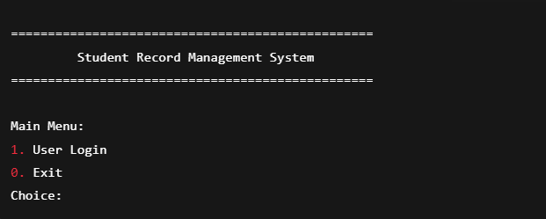
This startup interface provides access to the login system and clearly marks the available options for the user.

Login Section

After choosing the login option, the program requests secure login credentials:
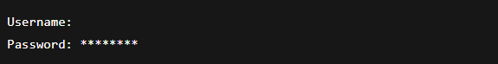
Depending on the authenticated user’s role (Admin / Staff / User), the corresponding menu is displayed, for example:

Admin Menu: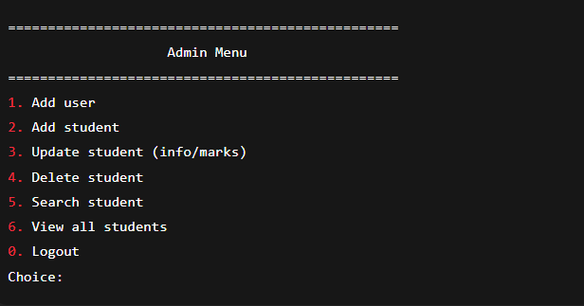
Role-based menus ensure secure and structured use of the system.

Input Section for Student Details
When adding a new student, the program requests information such as: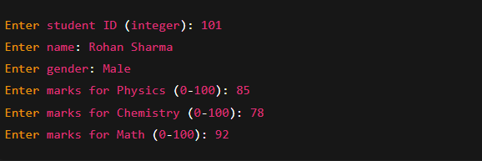
After all details are entered, the system:
- Validates each mark
- Computes total and average
- Automatically assigns a grade
- Saves the record to students.txt
A confirmation message follows:
Student added successfully with ID 101. Grade: A

Displaying a Student Record
When a student is searched by ID or name substring, the system displays: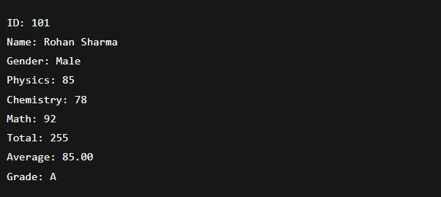
This format ensures clear visibility of academic performance.
Viewing All Records
Using the "View all students" option produces output such as:
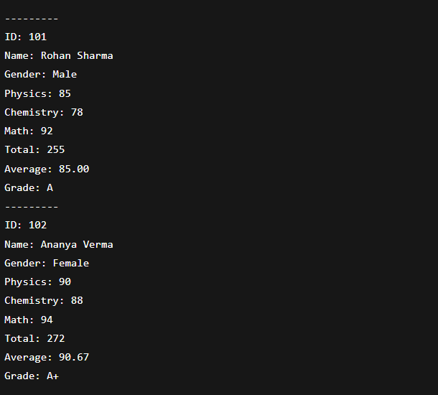

Update Confirmation Output
When a record is updated: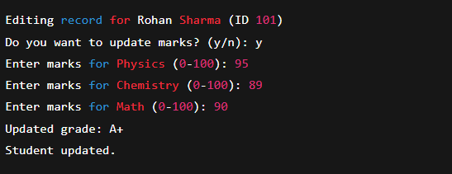

Deletion Confirmation Output
When deleting a student: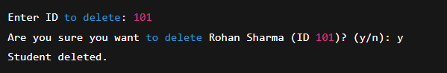

Conclusion
The Student Record Management System effectively demonstrates how the principles of structured programming in C can be applied to automate the process of storing, managing, and retrieving student academic records. The program collects essential details such as student ID, name, gender, and subject-wise marks, then accurately computes the total, average, and grade using well-defined functions. This automation reduces manual effort, minimizes the risk of calculation errors, and ensures consistent evaluation across all students.
The project makes strong use of core C programming concepts including structures, functions, arrays, loops, conditional statements, and file handling, resulting in a clean, modular, and easy-to-maintain system. The use of file handling provides permanent storage of data in students.txt, enabling records to be accessed, searched, updated, and deleted at any time. This greatly enhances the practicality, reliability, and long-term usability of the application.
The menu-driven interface offers a simple and user-friendly workflow for Admin, Staff, and User roles, making the system suitable for academic use. It demonstrates how automation can streamline repetitive tasks such as data entry, mark calculation, and record maintenance, thereby improving speed, accuracy, and overall efficiency.
Although the system successfully fulfills its core objectives, there is considerable potential for future improvement. The current implementation serves as a strong foundation for understanding real-world data management using the C language and highlights the value of automated systems in educational environments.
Future Scope
- Implement a graphical user interface (GUI) for improved usability.
- Integrate the system with an SQL database for scalable and secure data storage.
- Generate downloadable PDF report cards for students.
- Add features for email notifications of results or updates.
- Implement a more advanced and secure teacher/admin login system, including multi-factor authentication.

References
- Brian W. Kernighan and Dennis M. Ritchie, The C Programming Language, 2nd Edition, Prentice Hall (1988).
- “File Handling in C.” GeeksforGeeks.
https://www.geeksforgeeks.org/file-handling-c/ (Accessed December 2025).
- “C Structures.” Tutorials Point.
https://www.tutorialspoint.com/cprogramming/c_structures.htm (Accessed December 2025).
- “Working with Strings in C.” GeeksforGeeks.
https://www.geeksforgeeks.org/c-strings/ (Accessed December 2025).
- “User Authentication and Password Masking in C.” GeeksforGeeks.
https://www.geeksforgeeks.org/password-input-without-echo/ (Accessed December 2025).

